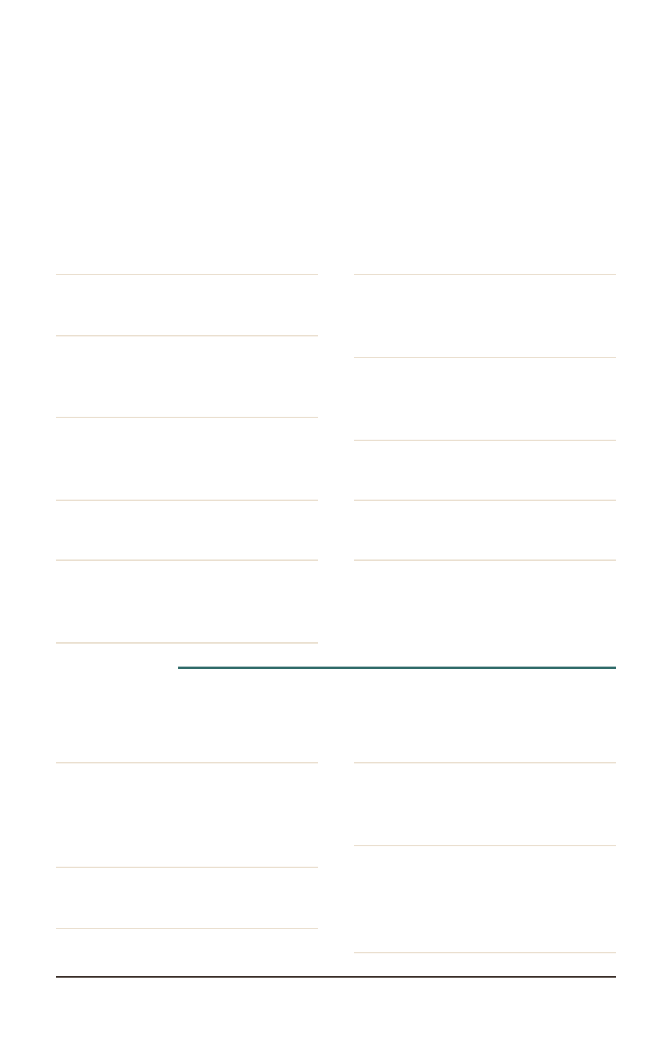
TKB DINER · COFFEE BAR
Specialty Drinks
As a latte, macchiato, frappe, shaken espresso, or cold brew
Apple Pie
Apple, brown sugar cinnamon,
and vanilla
Black Squirrel
Chocolate, hazelnut, and almond
Blonde
White chocolate, caramel, and
toasted marshmallow
Blueberry Pie
Blueberry, brown sugar
cinnamon, and vanilla
Caramel Kiss
Caramel and French vanilla
Fluffernutter
Peanut butter and toasted
marshmallow
Honeybee
Honey, rose or lavender, and
vanilla
London Fog
Earl Grey tea, vanilla, lavender,
and steamed milk
Nutty Monkey
Caramel, banana, and peanut
butter
Peppermint Patty
Chocolate and peppermint
Turtle
Chocolate, caramel, and toffee
SEASONAL
Book Worm HOT OR ICED
Brown sugar cinnamon, vanilla,
caramel, and cold foam
Detention FRAPPE
Cookies & cream, white
chocolate, vanilla, and whipped
cream
Hall Pass
Peach, coconut, lime, and Starry
School Spirit
Blue raspberry, strawberry,
coconut, and Red Bull
Straight A's
Strawberry, blue raspberry, lime,
and Red Bull
Teacher's Fuel
HOT, ICED, OR FRAPPE
Vanilla, caramel, hazelnut, and
white chocolate
Build your own drink on the back
(785) 562-3354
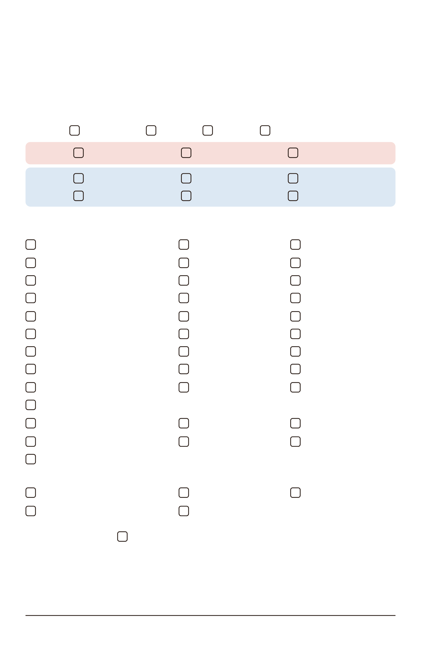
TKB DINER · COFFEE BAR
Build Your Drink
1
Pick a drink and size
SIZE
12 oz, hot
16 oz
20 oz
32 oz, iced
HOT
Latte
Macchiato
Americano
ICED
Latte
Macchiato
Americano
Shaken espresso
Cold brew
Frappe
2
Pick your add-ins
3 included · extras +1.25 each
Blue raspberry
Brown sugar cinnamon
Butter pecan
Crème de menthe
English toffee
French vanilla
Peanut butter
Salted caramel
Toasted marshmallow
White chocolate
Almond
Apple
Banana
Blueberry
Chai
Cherry
Cinnamon
Coconut
Hazelnut
Honey
Irish cream
Lavender
Peach
Peppermint
Raspberry
Rose
Strawberry
Vanilla
White chocolate sauce
Caramel sauce
Mocha sauce
Extra espresso shot
Oat milk
Almond milk
Cold foam
SUGAR-FREE
Brown sugar cinnamon
French vanilla
Pumpkin pie
Vanilla bean
White chocolate
3
Finish it
Whipped cream
Name
(785) 562-3354
Hand this card to your server

